
INSTRUCTOR: FAZLI CAN

TUGCE KEMEROZ - ASLI OZKAN - AYSE TARTAN

Week 12/02/2007-16/02/2007 Lecture Notes:

When we write a program we must design our programs to take correct output. For correct output, we use PSEUDO CODE. Although pseudo code similar to programming code, this code is not a real code. Purpose of the pseudo code is to create a map to be understandable.

For example;

a = x / 5 = +6 we learn that from this equitation x > 0

1. read x
If x > 0 then

a = x
else
a = -x
end ıf.

And print if “absolute value of “ x “is equal to” a

ABSRACTION: It means that make it easy. With abstraction, you can hide details, you show that what is done, how it is done.

For example;

- Read X
- Assign absolute value of x to a
- print a

>>>> TYPES OF PROGRAMMING<<<<<
↓↓↓↓↓ ↓↓↓↓↓ ↓↓↓↓↓

SEQUENCE SELECTION ITERATION

EX1 : Find summation of numbers 0 to n?

- Begin

- Read “n “

- sum = 0
i = 0
↓
↓

↓←←←←←←←←←←←←←←---------------------------------------------------
↓ ↑
--------------------------------------------------------------- ↑
TRUE | ------------------------ --------------- |
i <= 0 →→ | | sum = sum + i | ------- | i = i + 1 |-------
| | ------------------------ ---------------- |
--------------------------------------------------------------

↓
↓
FALSE
↓
Sum
↓
STOP

In programming we have int i, n, sum

If we write for PSEUDO code:

- Read n

- sum = 0

- i = 0

- if ( i < = n) then

- sum = sum + i
i = i + 1
End if

Print sum

Stop

NOTE: we do not write our programs with “GO TO “ because we have “FOR” instead of “GO TO”☺

With ABSTRACTION:
- read n
- sum = 0
- i = 0
- while ( I < = 0 )
sum = sum + i
i = i + 1
end while
- print sum

TYPES OF PROGARMMING
(programming paradigms)
Procedural Programming
Sequence
Selection(e.g if statement)
Iteration(e.g for, while statement
Object-Oriented Programming
Encapsulation
Polymorphism
Inheritance

TYPES OF PROGARMMING
(programming paradigms)
Procedural Programming
Sequence
Selection(e.g if statement)
Iteration(e.g for, while statement
Object-Oriented Programming
Encapsulation
Polymorphism
Inheritance

JAVA PROGRAM STRUCTURE

In a class definitio we have two key components:

- Variables
- Methods

And all of these components are encapsulated in the class.

A simple example of Java program

// This line and the following three lines are comments
Comment lines
// Example program
// ****************************************************

public class Example
{

Method
public static void main(String[] args)
{
The name of the library
System.out .print ("Hello");
System.out.println("world");
Parameter(argument you pass to the method print)
System.out.println();
System.out.println("Good bye!");

} // end of main()

}

OUTPUT
Hello world
……………(blank line)
Good bye!

☻ Be sure that you use meaningful names while creating your own variables!
☺And be careful for the indentation!

Identifiers

These are the words defined by using a railroad diagram.

- public , static ,void ...(RESERVED WORDS) (You can not use these words as variables)
- PROGRAMMER DEFINED IDENTIFIERS
  - Class name
  - Method name
  - Variable name

How can we construct our own identifiers?

Java letters : all letters (a…z , A…Z)
_ under score
$ dolar sign

Java digits(0…9)

Java letter

Java letter

Java digit

constant

System.out.println(“He is ” + 16 + “ years old.”);

Concatenation
or similarly...

int age =16;
System.out.prinln(“He is ” + age + “ years old.”);

When we say,
System.out.println(“He is “ + 16+1 +” years old.”);

OUTPUT
He is 161 years old.

When we say,
System.out.println(“ He is “ + (16+1) + “ years old.”);

OUTPUT
He is 17 years old.

Escape Sequences:
\b : backspare

\t: tab

\n: newline

\r: carriage return

\”:double quote

\’:single quote

\\ :backslash

If you write code in java :
System.out.println(“He said \”Please see me later.\”and didn\’t stop” );

Output:
He said “ Please see me later” and didn’t stop.

System.out.println (“He said”);
System.out.println(“Hello”);

OR
System.out println(“He said \n Hello”);

Output:
He said
Hello

Variable Declaration:

TYPES

VARIABLE DECLARATION
,

Variable Declarator:

IDENTIFIER

=
EXPRESSION

TYPE:

byte
short
int
long

***: final int KDV _RATE =18; If you write final in your code in java then you can not change it!!!

Primitive Data Types:

byte: 8 bits
short:16 bits
int: 32 bits
long: 64 bits

1,2,3 are : int
1.0 float point
“1” string “12”
‘1’char ‘12’

byte a ; 8 bits:

0000 0101
xxxx xxxx

ASCII: AMERICAN STANDART CODE FOR INFORMATION INTERCHANCE
8 bits:

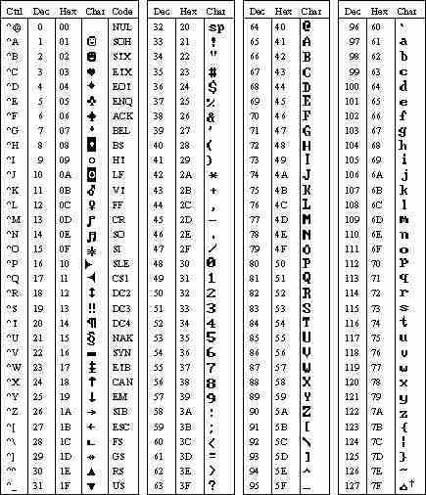

Questions:

- What is pseudo code? Why we need pseudo code in our programs?
- What is abstraction?
- Write a program which gives an output if result is negative. Write this program with pseudo code and abstraction.

- What are the difference between procedural programming and object oriented programming?
- What is the aim for writing comments while we are writing programs?
- Explain the difference between print and println methods?
- What does “concatenation” mean?

- What is the difference between println and print in java?Write outputs of following codes with using print method??
  - System.out.println(“Welcome To Java World!”);
  - System.out.println(“It’s First Step to be a Computer Enginer”);

- How Variable Declarator behave if you put final at the beginning of your variable?

10. What is ASCII why it is needed to do a table?? Write Decimal “39”,”43”,”126” in Hexa decimal by looking table ?? ☺

